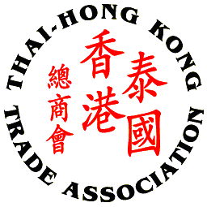
Thai – Hong Kong Trade Association

Celebration of the Mid-Autumn Festival 2015, September 22nd

(Ah Yat Abalone Forum Restaurant)

SPONSORSHIP FORM
Please complete this form and return to THTA at 02 343 9029
By September 15th 2015

Company/Sponsor Name: __________________________________________________________
Company Address: _______________________________________________________________
Contact Person’s Name: _______________________________ Position: _____________________
Tel No.: ___________________ Fax No.: __________________ Email: ______________________

Platinum Sponsor: 20,000 Baht plus VAT 7%
- 5 minutes company introduction & running company presentation
- 2 complimentary tickets
- Booth and/or sponsor’s promotional activities
- One roller-up banner to be provided by sponsor
- Company name/logo prominently displayed on the e-invitation and the event
- Company name on all correspondence / Thank you letters
- Recognition of contribution on website

Gold Sponsor: 10,000 Baht plus VAT 7%
- 5 minutes company introduction
- 1 complimentary ticket
- One roller-up banner to be provided by sponsor
- Company name/logo prominently displayed on the e-invitation and the event
- Company name on all correspondence / Thank you letters
- Recognition of contribution on website

Silver Sponsor: 5,000 Baht plus VAT 7%
- One roller-up banner to be provided by sponsor
- Company name/logo prominently displayed on the e-invitation and the event
- Company name on all correspondence / Thank you letters
- Recognition of contribution on website

Prize Donor
- Thank you remark by MC during the dinner
Cheque payment to be made to: Thai - Hong Kong Trade Association
Payment Option: Direct transfer to Krung Thai Bank, Queen Sirikit National Convention Center Branch, Saving Account, A/C No. 009-1-726-336
Remark: Please fax payment slip when you have paid via direct bank transfer to 02 343 9029 or E-mail to thai-hongkong@thta.or.th

